Query the names of all the Japanese cities in the CITY table. The COUNTRYCODE for Japan is JPN.

Input Format

The CITY table is described as follows:

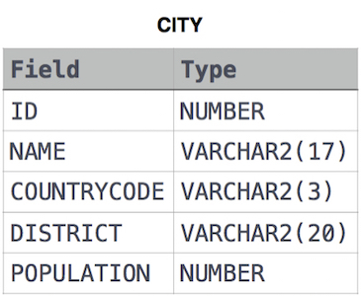

Solution :

SELECT NAME

FROM CITY

WHERE COUNTRYCODE LIKE 'JPN';